Assignment-1
NAME:Muskan kumari(2501010265)
AIM:Implement NOT, AND,OR gates using NAND gates using NAND2TETRIS simulation SCHEMATIC Diagram, Boolean Expression and Truth Table
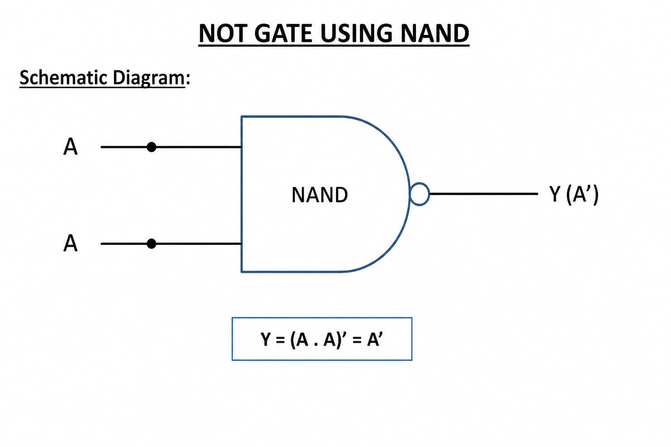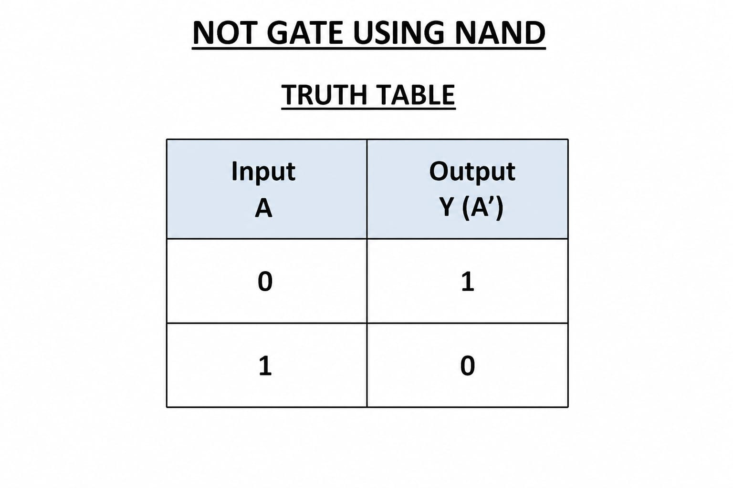
Code: CHIP Not {
IN in;
OUT out;

PARTS:
Nand(a=in, b=in, out=out);
}
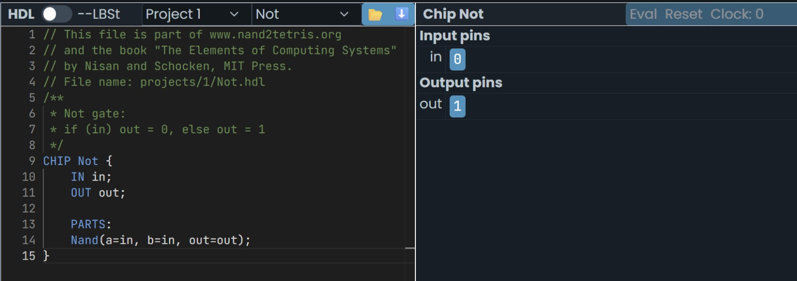
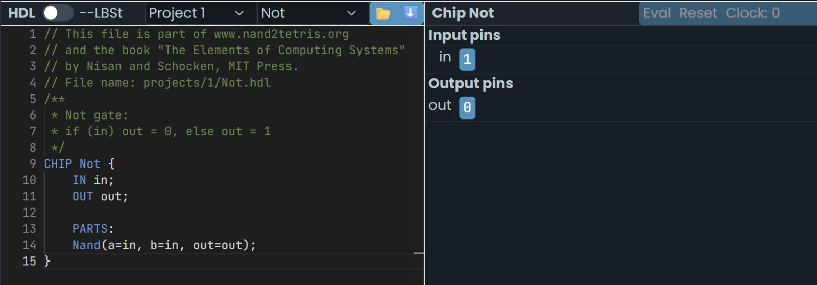
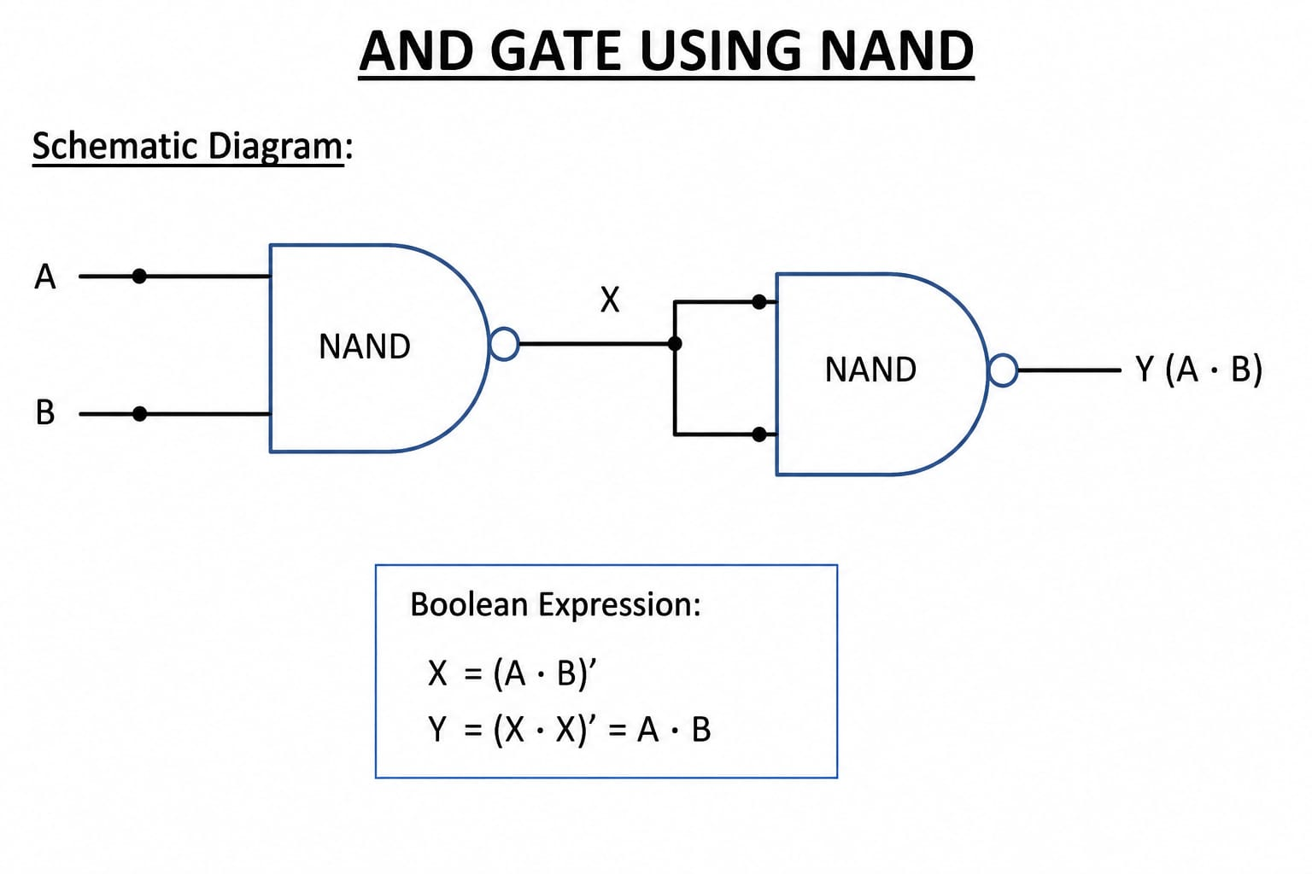
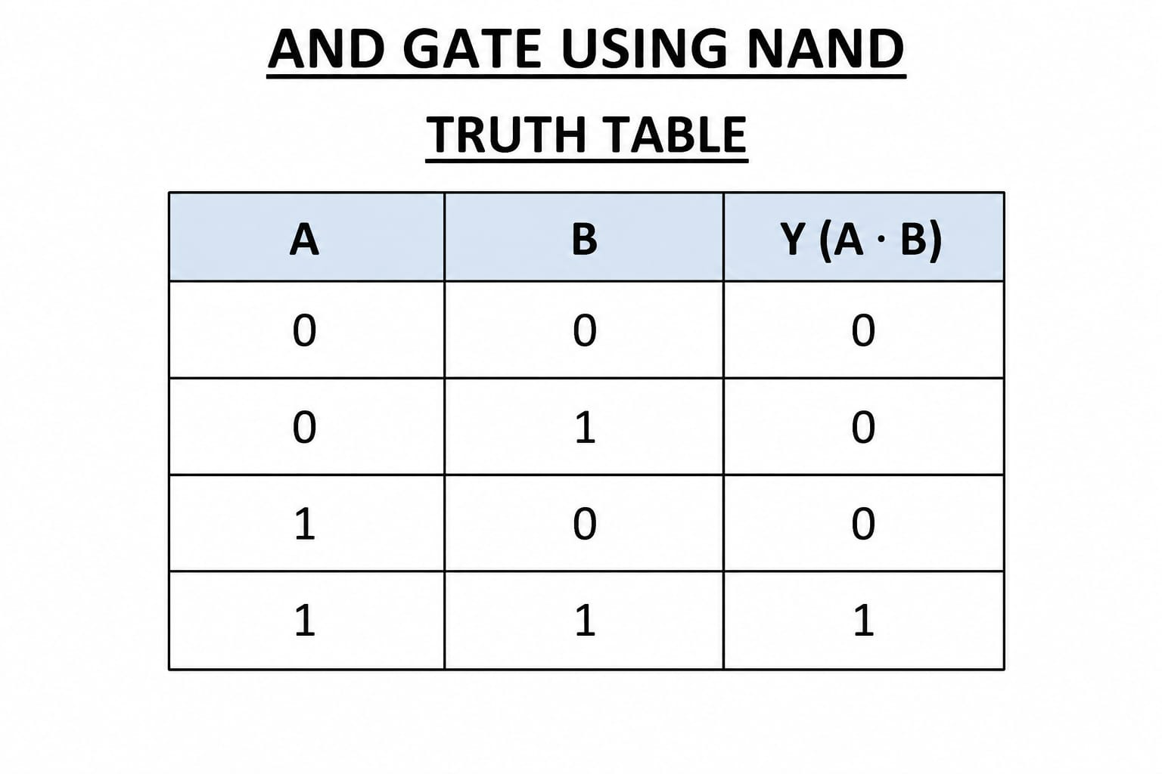
CODE:
CHIP And {
IN a, b;
OUT out;

PARTS:
Nand(a=a, b=b, out=temp);
Nand(a=temp, b=temp, out=out);
}

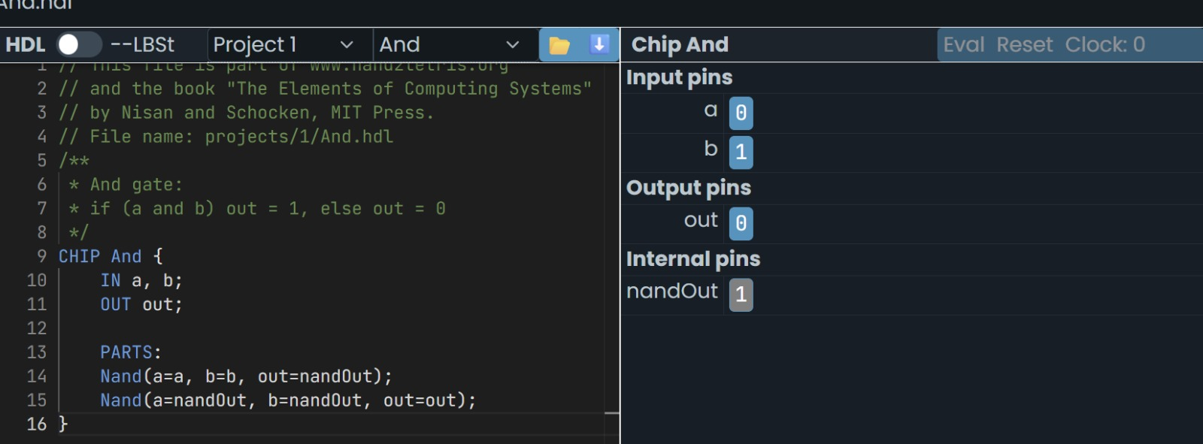
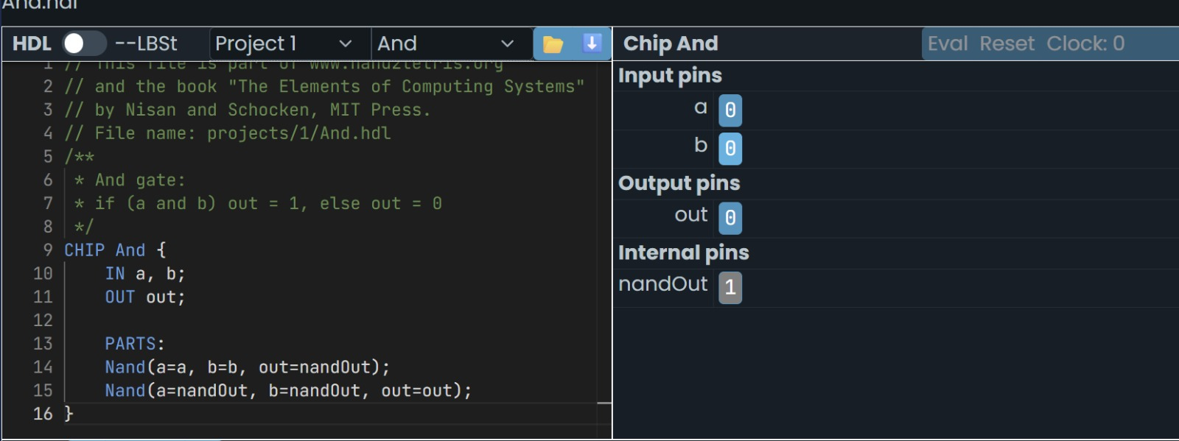
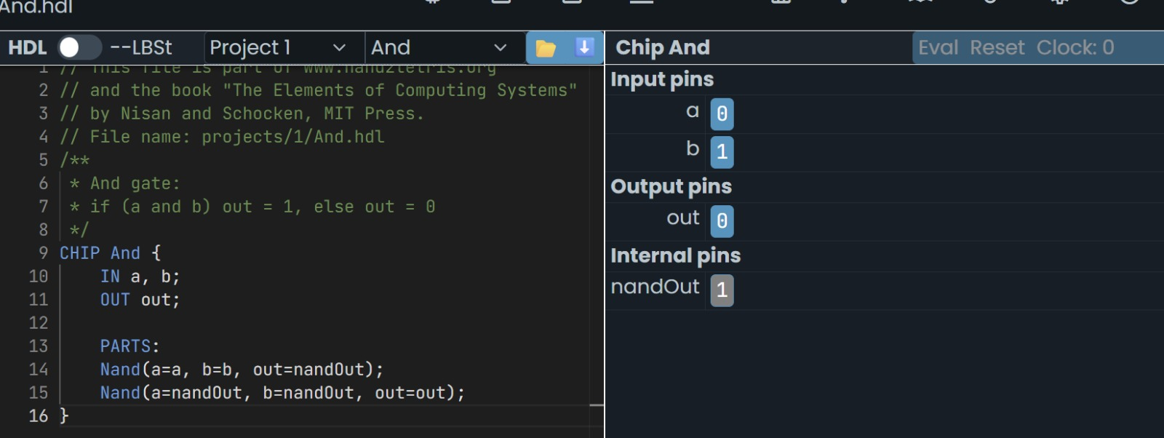

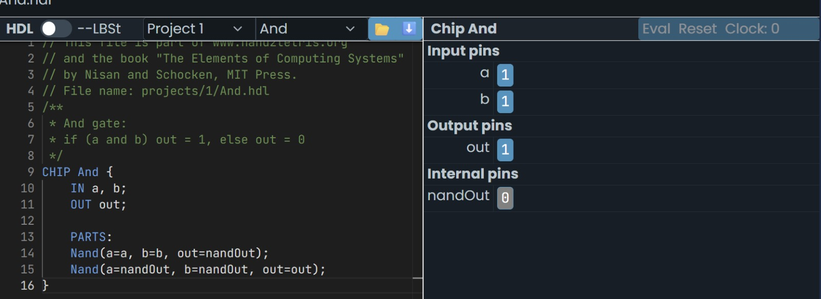

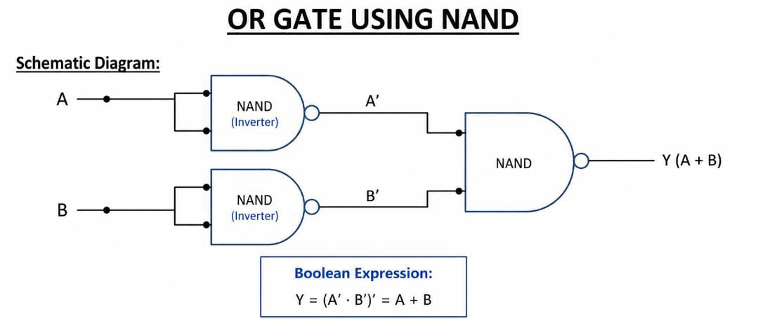
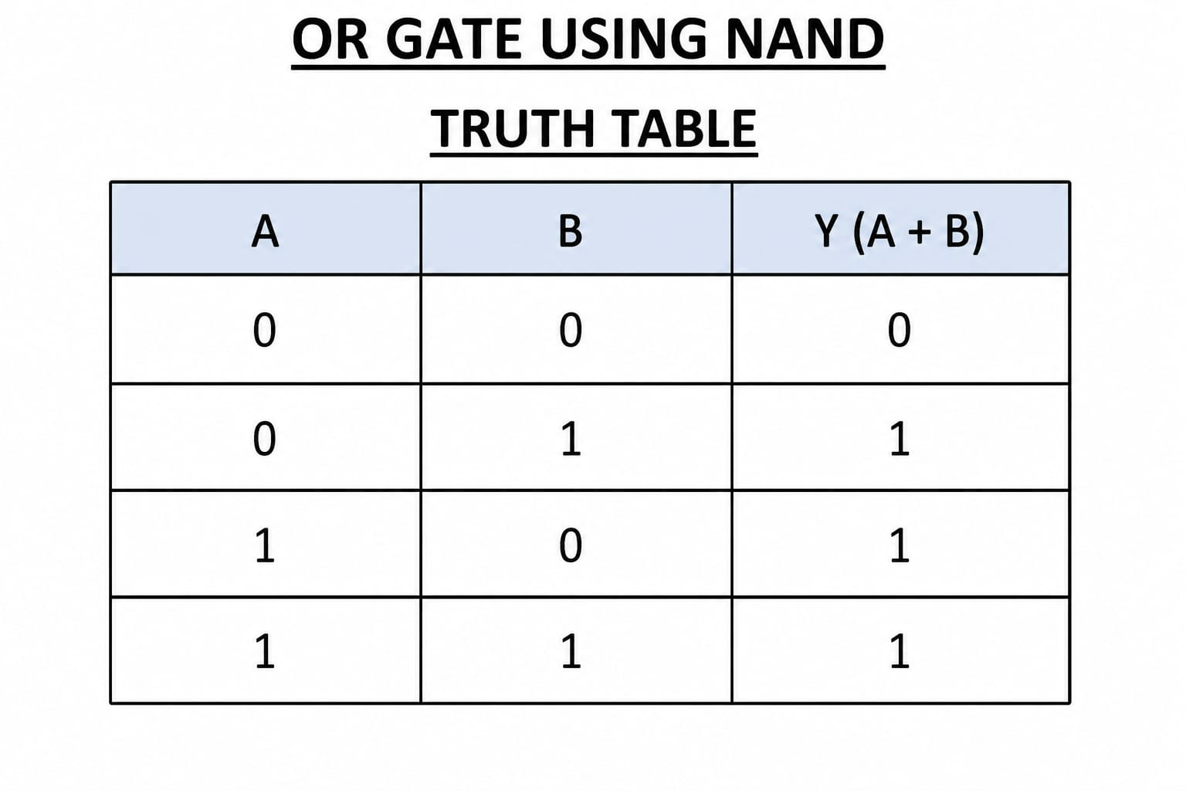

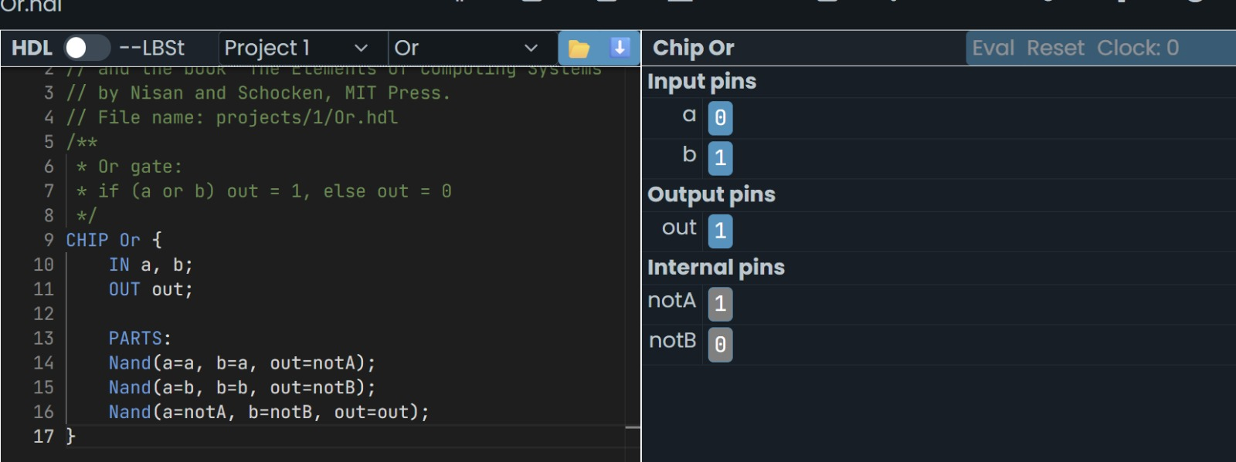
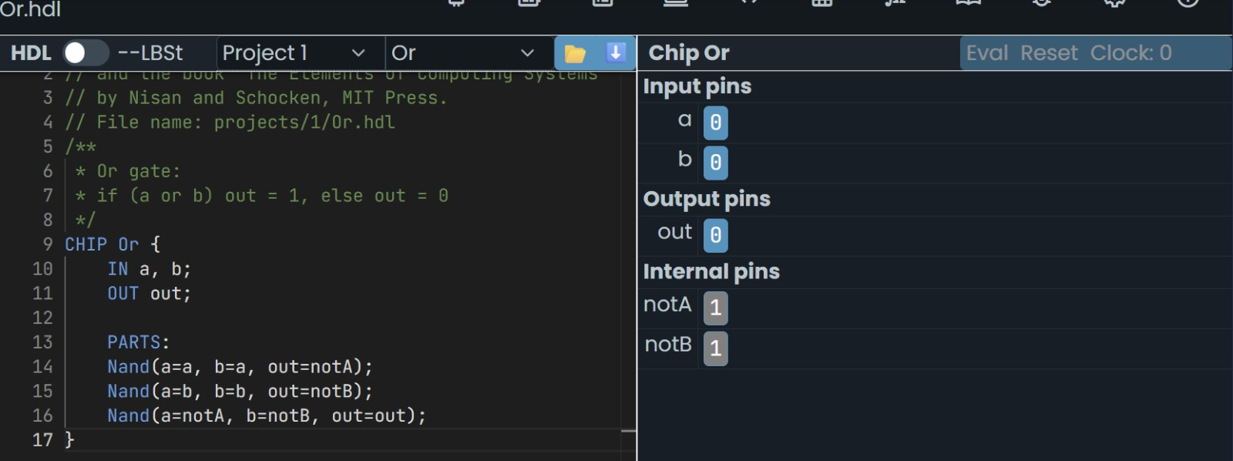
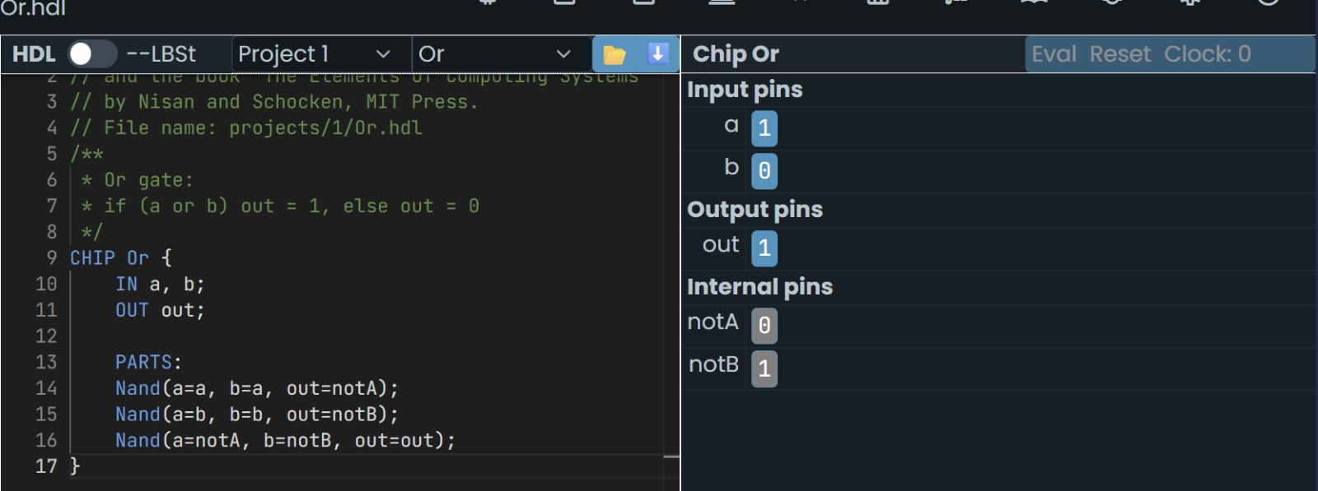
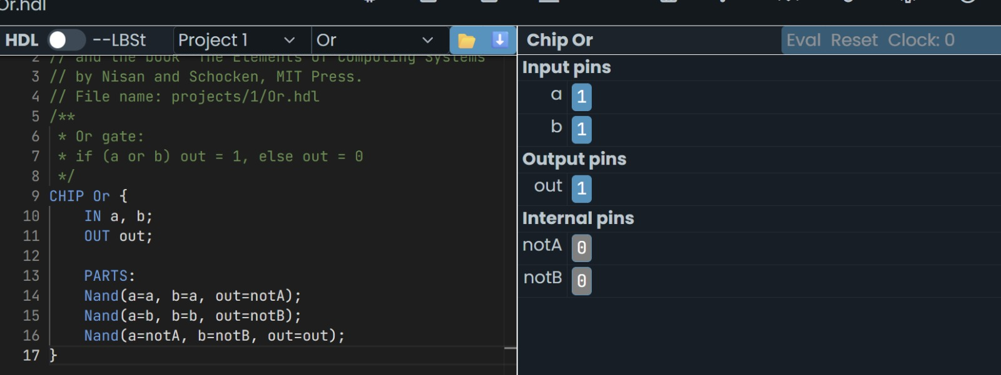
CODE: CHIP Or {
IN a, b;
OUT out;

PARTS:
Nand(a=a, b=a, out=nota);
Nand(a=b, b=b, out=notb);
Nand(a=nota, b=notb, out=out);
}

